**Oppenheim, Meret Elisabeth (1913-1985)**

Meret Oppenheim was a Swiss artist primarily known as a maker of Surrealist objects. Born in Berlin-Charlottenburg to a German father and Swiss mother, Oppenheim spent most of her youth in Switzerland until, at the age of eighteen, she travelled to Paris to become an artist. Although enrolled at the Académie de la Grande Chaumière, Oppenheim preferred to work independently and, in 1933, her friendship with fellow Swiss artists Hans Arp and Alberto Giacometti led to an invitation to participate in the Surrealist Salon des Surindépendents. She subsequently became a part of the group focused around André Breton at the Café de la Place Blanche, continuing to exhibit with the Surrealists until returning to the family home in Basle in 1937, where she attended the School of Arts and Crafts for two years. A long period of depression and artistic crisis ensued during which Oppenheim destroyed much of her work. During the postwar period she became increasingly estranged from the remains of the Surrealist group, perceiving it as entrenched in the past. Her own solo career was belatedly developing and, with the advent of feminism, she was increasingly recognised as a role model for independent women artists. In 1975 Meret Oppenheim was the beneficiary of the Art Award of the City of Basle, and in 1982, the same year that she took part in Documenta 7 in Kassel, she was awarded the Art Prize of the City of Berlin.

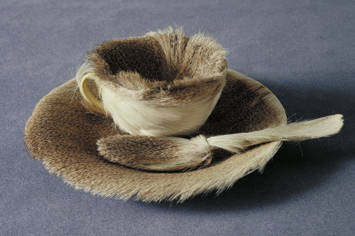

Meret Oppenheim *Breakfast in Fur* 1936

<http://en.wikipedia.org/wiki/File:M%C3%A9ret_Oppenheim_Object.jpg>

In 1936 Meret Oppenheim’s *Le Déjeuner en Fourrure* (Breakfast in Fur) was purchased by Alfred H. Barr for the collection of the Museum of Modern Art in New York. The most famous of all Surrealist objects, this was a coffee cup, saucer and spoon transformed into an enigmatic emblem of Surrealist desire by the addition of a covering of Chinese gazelle skin. However, Oppenheim’s own recognition as an artist was overshadowed by her reputation as an eroticised icon of Surrealist womanhood as a result of an earlier collaboration with Man Ray in the winter of 1933-34. This included photographs in which Oppenheim posed nude behind the wheel of a printing press, her upturned arm blackened with printing ink; one of these photographs was subsequently published in the journal *Minotaure* in 1934 to accompany Breton’s seminal essay on the Surrealist aesthetic.

Oppenheim’s lack of recognition as an artist was a major factor in her prolonged period of depression. Her lifelong interest in the work of Jung, however, provided an avenue that helped her to reach a feminist understanding of a fundamental androgyny within the notion of creativity, despite the role of patriarchy in frequently denying women artists the ability to reach their full potential. Oppenheim affirmed this in her acceptance speech for the Basle Art Award in 1974: ‘Men, as artists, can live as they please without provoking censure, but people look disdainfully on a woman who claims the same privilege (…) Nobody will give you freedom, you have to take it’. Objects such as *Ma Gouvernante, Mein Kindermädchen, my nurse* (1936), a pair of upturned white court shoes trussed together on a serving platter, became celebrated by a new generation of feminist artists asembodying the transformation of an everyday object into an a subversive critique of the restrictions imposed on women in a patriarchal culture. Much of Oppenheim’s subsequent work, however, including painting, drawing and photography, continued to reveal a fascination with processes of metamorphosis identified with the power of nature as in the sculpture *The Green Spectator* (1959) or the painting *The Secret of Vegetation* (1972), with its DNA-like spirals curling upwards towards a blue sky. This painting also embodies the relationship of abstraction and representation, a theme that preoccupied Oppenheim for much of her later career.

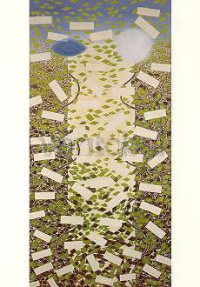

Meret Oppenheim *The Secret of Vegetation* 1972

[**http://www.vontobel-art.com/en/Oppenheim-Meret/The-Secret-of-Vegetation-aid53744**](http://www.vontobel-art.com/en/Oppenheim-Meret/The-Secret-of-Vegetation-aid53744)

**References and Further Reading**

Oppenheim, M. (1975), ‘Acceptance Speech for the 1974 Art Award of the City of Basel, January 16, 1975’, in B. Curiger ed. *Meret Oppenheim: Defiance in the Face of Freedom,* 1989,Zurich-New York: Parkett: 130-131

(Most important statement of Oppenheim’s feminist and artistic beliefs. Curiger’s book is the first extensive account of Oppenheim’s career in English in addition to a catalogue raisonné).

J. Burckhardt and B.Curiger eds. (1996) *Meret Oppenheim: Beyond the Teacup,* New York: Independent Curators Incorporated. (This well illustrated exhibition catalogue also contains essays by Thomas McEvilley, Josef Helfenstein and Nancy Spector).

H. Eipeldauer, I.Brugger, G. Sievernich eds, (2013) *Meret Oppenheim: retrospective* Hatje Kanz. Extensively illustrated catalogue of Oppenheim’s Berlin retrospective of 2013, also including some of her writings; wide-ranging critical essays provide a much-needed account of the diversity of her interests.

*IMAGO: Meret Oppenheim* (1990, 90mins) Award-winning film by Pamela Robertson-Pearce and Anselm Spoerri. Narration based on Oppenheim’s texts, letters, dreams and poems by Glenda Jackson: extract available on Vimeo <http://vimeo.com/3894796>

Chadwick, W. (1984) *Women Artists of the Surrealist Movement,* London: Thames and Hudson (An important yet accessible study of women in the Surrealist movement, including Meret Oppenheim).